Using computer-based models to understand the relationship between health and employability: how a small health disadvantage could cause a big employment disadvantage in a competitive labour market

# Jonathan Minton

Health Economics and Decision Sciences,

School of Health and Related Research,

The University of Sheffield

Regent Court

30 Regent Street

Sheffield

S1 4DA

# Keywords:

Economics; self-rated health; socio-economic; modelling; employment

# Word count - 2328

# Abstract

**Introduction**

Recent research suggests it has become harder in recent decades and in the UK for people with limiting longstanding illnesses to find employment. Rates of reported limiting longstanding illnesses have been stable, but the disadvantage such illness has conferred on employability has increased substantially. This paper uses a simple computer based model to formally explore how this may have occurred.

**Method**

A stylised model was developed in which job seeking is considered a ‘winner takes all’ process which rewards only the ‘best’ candidate. It simulates the probability of a candidate with some degree of health based disadvantage achieving a job offer following an application, given both the degree of health based disadvantage and the number of competitors for that position.

**Results**

The model predicts that, when there are larger numbers of candidates per position, slight disadvantages in performance due to ill health could result in a large employability disadvantage, so a level of health disadvantage which would not render someone unemployable when labour markets are less competitive could exclude them from more competitive labour markets.

**Discussion**

The use of the stylised model means the logical implications of assumptions can be scrutinised. A more competitive labour market may be more likely to disproportionately exclude people in poorer health than generally assumed, and so the level of health necessary to avoid becoming socially excluded in this way could have increased as a result of economic changes in the UK over the last thirty years.

# Introduction

Recent research has indicated that people of working age who report limiting longstanding illness (LLTI) are much less likely to be employed and much more likely to be economically inactive than they would have been a generation ago, and that this relationship is much stronger for people with unskilled manual labour backgrounds than other occupational groups. [1,2] Self-assessed health has not worsened in this or other European countries over this time, but the employability disadvantage associated with having a LLTI has. [3] This paper describes a computer-based model which has been developed to explore how this could have happened.

The computer-based model incorporates just two parameters, one relating to ill health of a candidate, and another to the number of competitors for a position. The model assumes that getting a job is essentially a ‘winner-takes-all’ process, in which the best of a number of candidates for a job get all of the reward (a job), and all other candidates get nothing. Using a computer-based model in this way is useful as a tool for demonstrating the logical implications of making particular assumptions in a complex system incorporating nonlinearities, where these implications may not be immediately apparent. The model was constructed in R, and the code is presented in the appendix.[4,5]

# Methods

Mathematical models are commonly used in health technology assessments to help NICE and other health based decision making organisations make coherent, evidence-based decisions. [6] The role of this model is more as tool for exploring the logical ecological consequences of accepting a series of individual level assumptions about job selection processes.[7] Because of nonlinearities, small changes at the individual level can lead to large changes at the ecological level [8–10] These logical implications may not be apparent without adopting a formal model, because it is more intuitive to assume that inputs and outputs are broadly proportional to one another. [11]

## Assumptions modelled

The assumptions made in the model are: 1) that getting a job is essentially a winter-takes-all process; 2) that health is one of a number of factors that influences how ‘fit’ a candidate is likely to be for a job; 3) that people have ‘good days’ and ‘bad days, variation in performance, but that this variation is around a central level; 4) that people in poorer health have on average a lower level of job fitness than otherwise similar people in good health.

To assume that getting a job is essentially a winter-takes-all process is to say that if one candidate’s performance in the selection process is 95% as good as another candidate’s, then this candidate will not receive 95% of the ‘reward’ for this performance. This is the assumption that means the relationship between inputs and outputs can be nonlinear.

Two further assumptions are that: each candidate has an ‘average’ level of fitness; and that there is some level of variation around that average level; and that there are fundamentally just two types of candidate – healthy candidates and health impaired candidates – who apply for jobs. Additionally, there is the assumption that if a person’s employability falls below a certain threshold then they effectively become ‘unemployable’. If, for example, a 62 year old has specialised for the previous 40 years in a particular occupation, and there are currently only 10 new opportunities in that field per year, and the candidates needs on average to apply for 100 positions to be offered one job then it will take that person on average 10 years to get a job. If the retirement age is 65 then that person is effectively ‘unemployable’ as they could expect employment *after* they are due to retire, and so due to move beyond working age.

## The model

The model is implemented as follows: a job selection process is represented by selecting from a series of candidates who each demonstrate a given level of performance of that position. The performance that each candidate demonstrated on that occasion is represented by a random draw from that particular candidate’s ‘performance distribution’. The ‘healthy’ candidates are all represented by the same performance distribution, and the health impaired candidates by this same distribution by shifted down by a given amount, d. The model simulates the proportion of trials where a health impaired candidate ‘wins’ a job over one or more healthy candidates.

A number of variations of this model are run, for a wide range of permutations of k, the number of healthy candidate the health impaired candidate completes against, and d, the degree of job fitness disadvantage due to ill health that the health impaired candidate has. In order to operationalise the model, the Normal distribution was used to represent variation in candidates’ performance, and the results are likely to be somewhat contingent this choice of distribution. The process is shown graphically in Figure 1 below. In this graphical representation B represents the distribution from which the health-impaired candidate’s apparent job fitness is drawn, and A represents the distribution from which the candidate in full health’s job fitness is drawn. Paired draws from each distribution are drawn four times, to represent four attempts to win a job. Candidate A’s performance, represented by the long black link, is superior on the first three occasions, and so is selected. Candidate B, represented by the shorter grey line, demonstrates superior performance on the fourth occasion, and so is successful on this occasion.

**Employer’s appraisal of candidate’s job fitness**

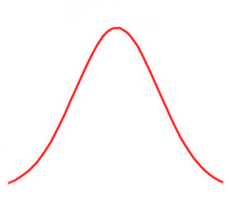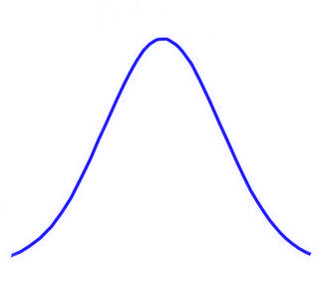

B

A

*d*

***Job 1***

***Job 2***

***Job 3***

***Job 4***

*Worse*

*Better*

Figure Stylised job selection model

Although an analytic solution to the problem is possible when using this distribution, the simulation approach has the advantage of being relatively easy to produce and follow, so of course being readily adaptable to the other distributions and the incorporation of different assumptions and layers of simulation complexity.

# Results

Where there is a single job rival in full health, the relationship between the degree of health-related disadvantage, d, and the probability of a successful job application is shown in Figure 2 below. The probability of the disadvantaged candidate presenting as the better candidate decreases monotonically with the degree of disadvantage.

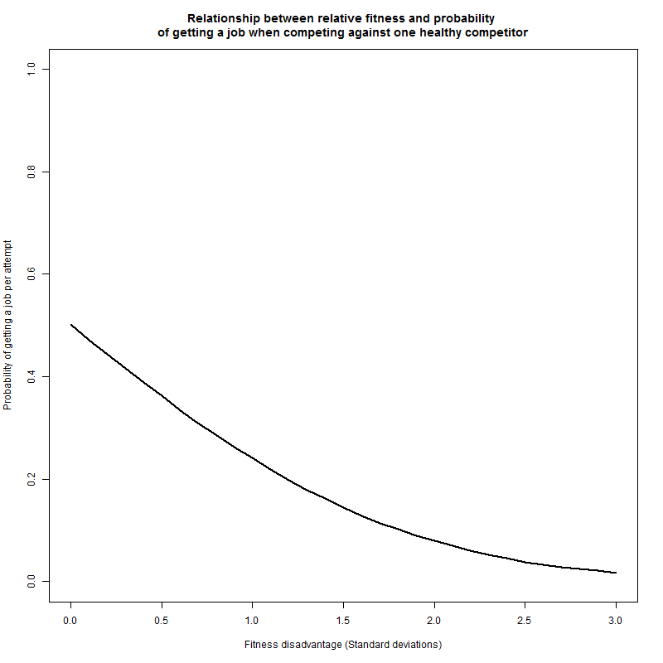

Figure Simulated relationship between probability of winning a for a health impaired candidate as a function of degree of disadvantage, when competing against one competitor in full health.

The relationship between the number of healthy competitors, k, and the probability of the health impaired candidate presenting as the best candidate is illustrated in Figure 3. In this figure, the degree of disadvantage d has been held constant at 0.5, i.e. half a standard deviation below the mean fitness level of the candidates in full health. As the number of competitors increases, the probability of the health impaired candidate winning the job decreases. Because of the initial disadvantage, however, the probability of getting the job is lower than what would be expected of a nonimpaired candidate irrespective of the number of candidates.

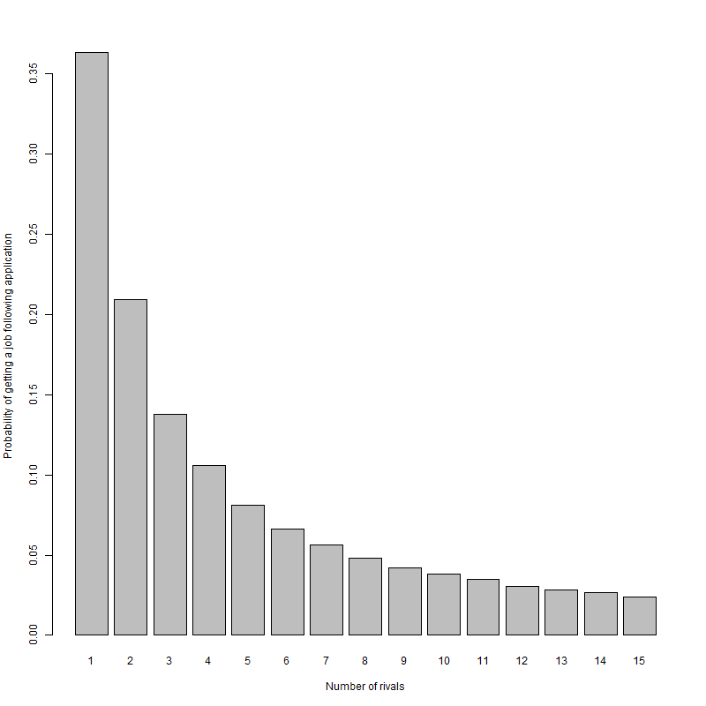

Figure Simulated probability of winning a job for a health impaired candidate with d=0.5, as a function of the number of other candidates for that position in full health

The way that the number of competitors k and degree of disadvantage d jointly affects the probability of getting a job is shown in Figure 4below. Figure 5 presents the same relationship using the equivalent measure, expected number of applications necessary to get a job. It is seen that someone with a given level of health disadvantage will face an increasing challenge to their chances getting a job as the number of competitors per place increases. It is further noted that this relationship is nonlinear, such that both d and k have to be specified in order to identify what the effect on employability is. As has been stated previously, the precise values predicted have not been calibrated empirically, and just exist to show how this nonlinear relationship could emerge as a result of modelling a series of relatively innocuous assumptions about social and economic factors which could mediate health factors.

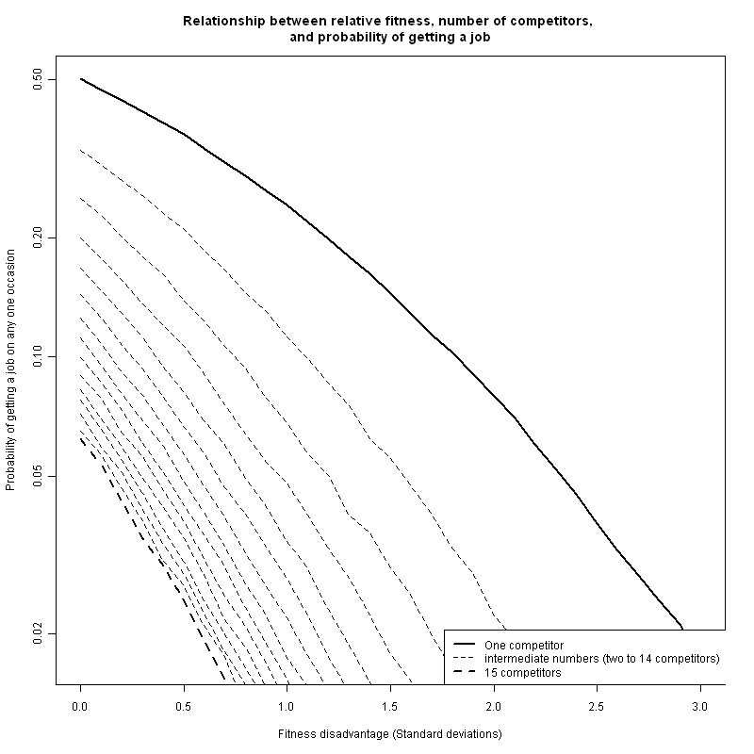

Figure Joint simulated relationship between health disadvantage, number of competitors, and probability of winning a job per attempt

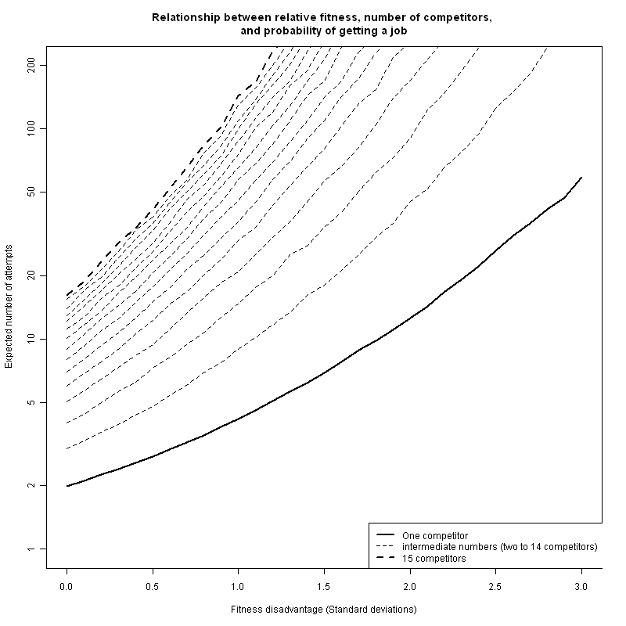

Figure 5 Joint relationship between health disadvantage, number of competitors in full health per job, and expected number of attempts to secure one job

## Unemployability thresholds

If we assume that someone who requires on the average 200 applications to receive one job offer, equivalent to a probability of 0.005, is effectively ‘unemployable’, then we can observe how increased competition for jobs (increased k) will push an increasing proportion of the working age population into the ‘unemployable’ category.

With just one competitor per job, the degree of fitness disadvantage d required to reach this threshold is 2.3, with two competitors the d required to reach this threshold reduces to 1.6, and with three competitors to 1.3. This relationship continues with each addition competitor. In the example presented, with 15 unimpaired competitors per place, a person becomes ‘unemployable’ when their d level is only 0.2. Note that d refers only to the degree of disadvantage relative to the average ,and does not imply the proportion of the population with that level of d. A further nonlinear relationship between k, d, and the proportion of the population affected may be assumed, in that if the ‘unemployability’ threshold reaches a d level that is relatively common in the working age population, then a large rise in economic inactivity may emerge.

# Discussion

## Findings

This model indicated that it may be plausible to assume that a level of health impairment that would not have been severe enough to exclude people from the labour market in the 1970s could nevertheless exclude people from the labour market in the 1990s and beyond. This is because of the proposed relationship between health impairment and labour market competitiveness, represented in this model by the number of competitors for a position.

## Shortcomings

The purpose of this model is primarily as a way of testing and demonstrating the logical implications at the ecological level of combining a number of relatively uncontroversial individual level assumptions. The potential shortcomings of the model are that these individual level assumptions are inadequate, either due to being incorrect or excessively simplistic. Another potential shortcoming of the model is that the Normal distribution was used to represent both impaired and nonimpaired jobseeker populations, and the dependency of the results presented on these assumptions have not been full assessed. The model here is intended primarily as a pedagogic tool for encouraging clearer thinking about this important public health issue. In using a model in this way it is important that the right balance is struck in terms of model sophistication and model accessibility. If the appropriate balance has not been struck then this is a shortcoming of the model.

## Relationships with other findings

This stylised model owes a conceptual debt to work by Beatty, Fothergill and McMillan in relationship to ‘hidden unemployment’, and so its relationship to this research is not coincidental. [12,13] This research suggested that, during the early 1990s, there may have been a large number of people in employment whose degree of health impairment was severe enough that they would have met the eligibility criteria for incapacity benefit or invalidity benefit. However, this latent ill health among the working age population only became realised as increased invalidity benefit (IVB) or incapacity benefit (IB) claims when the recession of the early 1990s occurred, as less healthy members of the workforce may have been both most likely to be made redundant and least likely to find new employment. Faced with a choice between remaining on unemployment benefits with only limited expectation of finding a new job, or of making a legitimate claim for IVB/IB, which paid more and did not have the same jobseeking conditionality, many of the less healthy people laid off during this recession may have made the economically rational choice, and in doing so permanently exited the labour market.

Recent research by this author has indicated a complex relationship between gender, occupational class, and limiting long term illness as predictors of whether people are in work, seeking work or economically inactive. [1] In particular, this research showed that the presence of a limiting long-term illness was much more strongly associated with being economically inactive for people of unskilled and semi-skilled manual labour backgrounds than nonmanual backgrounds; additionally, it showed this relationship to have grown much stronger since the 1970s. In terms of the variables included in this stylised model, there are two possible, and not mutually exclusive, explanations for these observations. Firstly, it may be that a ‘limiting long-term illness’, as responders were asked to interpret it, was more likely to be a physical than a mental disorder, and as a result was likely to be the sort of health deficit which led to a larger job-specific health deficit for manual than non-manual work. Secondly, the long transition towards an increasingly post-industrial economic is likely to mean that there is a greater scarcity of manual than nonmanual work, and so k is greater for these occupational groups than non-manual workers.

## Implications for research

This paper has illustrated the potential benefits of a formal, simulation based approach to thinking about epidemiological processes and aetiology in complex social systems. This model is very simple, and could be made more sophisticated by incorporating potentially relevant individual level effects such as in-group selection preferences, social networks, microeconomic incentives, and gender differences. [14–18] The model could then incorporate available empirical evidence and calibrated by comparing the predictions of the model to reality over periods where the data are already known. [19–21] In other epidemiological areas, the spirit of the approach described here could be followed to encourage health researchers to adopt the stylized and pedagogic modelling approach for exploring other complex health science areas.

## Implications for practice

If the assumptions and simplifications involved in producing this model are accepted as adequate representations of the relationship between health and labour market selection, then a practical implication of this research is that a side effect of making labour markets more competitive may have been to increase health-based social exclusion. As a result of this, adequate management of limiting long-term illnesses may be central to helping to reduce the degree of labour market exclusion experienced by people of working age and in poorer health. In highly competitive labour markets, even slight health disadvantages may mean that, although people may still be capable of performing a wide range of work to a good standard, they would be unlikely to be given the opportunity to demonstrate that aptitude. Because of this, ‘supply side’ welfare reform interventions may be unlikely to succeed unless combined with significant ‘demand side’ interventions for incentivising employers to consider candidates they might otherwise reject.

# Bibliography

1 Minton JW, Pickett KE, Dorling D. Health, employment, and economic change, 1973-2009: repeated cross sectional study. *BMJ* 2012;**344**:e2316–e2316.

2 Bartley M. Economic inactivity and health. *BMJ* 2012;**344**:e2858–e2858.

3 Kunst AE, Bos V, Lahelma E, *et al.* Trends in socioeconomic inequalities in self-assessed health in 10 European countries. *International journal of epidemiology* 2005;**34**:295–305.

4 Team RDC. R: A language and environment for statistical computing. 2011.http://www.r-project.org/.

5 Sarkar D. *Lattice: Multivariate Data Visualization with R.* New York: : Springer 2008.

6 NICE. Guide to the methods of technoloy appraisal. 2008.

7 Nettle D. Why are there social gradients in preventative health behavior? A perspective from behavioral ecology. *PloS one* 2010;**5**:e13371.

8 Gilbert N, Troitzsch KG. *Simulation for the Social Scientist*. Second Edi. Maidenhead: : OUP 2005. http://cress.soc.surrey.ac.uk/s4ss/S4SS-sample-chapter.pdf

9 Schelling T. *Micromotives and Macrobehaviour*. London: : V W Norton & Company Ltd. 1978.

10 Ormerod P. *Why Most Things Fail: Evolution, Extinction and Economics*. London: : Faber & Faber 2005.

11 Nisbett R, Wilson TD. Telling More Than We Can Know: Verbal Reports on Mental processes. *Psychological Review* 1977;**84**:231–59.

12 Beatty C, Fothergill S. The diversion from “unemployment” to “sickness” across British regions and districts. *Regional Studies* 2005;**39**:837–54.

13 Beatty C, Fothergill S, Macmillan R. A Theory of Employment, Unemployment and Sickness. *Regional Studies* 2000;**34**:617–30.

14 Becker G. The Economic Way of Looking at Life. In: Persson T, ed. *Nobel Lectures, Economics 1991-1995*. Singapore: : World Scientific Publishing 1997. http://www.nobelprize.org/nobel_prizes/economics/laureates/1992/becker-lecture.html

15 Beatty C, Fothergill S, Houston D, *et al.* A gendered theory of employment, unemployment, and sickness. *Environment and Planning C: Government and Policy* 2009;**27**:958–74.

16 Granovetter MS. The Strength of Weak Ties. *American Journal of Sociology* 1973;**78**:1360–80.

17 Tajfel H. *Differentiation between social groups: Studies in the social psychology of intergroup relations*. London: : Academic Press 1978.

18 Lorant V, Bhopal RS. Ethnicity, socio-economic status and health research: insights from and implications of Charles Tilly’s theory of Durable Inequality. *Journal of epidemiology and community health* 2011;**65**:671–5.

19 Scarborough P, Nnoaham KE, Clarke D, *et al.* Modelling the impact of a healthy diet on cardiovascular disease and cancer mortality. *Journal of epidemiology and community health* 2012;**66**:420–6.

20 Watkins W, Roberts ZES, Dunstan FD, *et al.* An investigation through microsimulation of the inequities in Coronary Heart Disease (CHD) mortality and morbidity in Wales . *Journal of Epidemiology and Community Health* 2011;**65** :A11–A12.

21 Ballas D, Clarke G, Dorling D, *et al.* SimBritain: A spatial microsimulation approach to population dynamics. *Population Space and Place* 2005;**11**:13–34.